# Italy – Source URL Analysis

**Official URL**: <https://www.gazzettaufficiale.it/30giorni/serie_generale>

The Gazzetta Ufficiale is Italy’s official publication for legal acts, managed by the Istituto Poligrafico e Zecca dello Stato under the responsibility of the Ministry of Justice.

The site has an advanced search feature accessible via the [Ricerca Avanzata (Advanced Search)](https://www.gazzettaufficiale.it/ricerca/atto/serie_generale/originario?reset=true&normativi=true). We used only the Parole nel titolo (Words in the title) function, selecting la seguente frase (the following sentence), to search for legal acts using exact keyword matches. The search was conducted using the Italian keywords without quotation marks (e.g., pari opportunita).

For KLI: We would like to confirm one assumption we made during this analysis. The URL you provided points to the General Series, which we understand to be the primary source for extracting the national laws and decrees related to ESG.

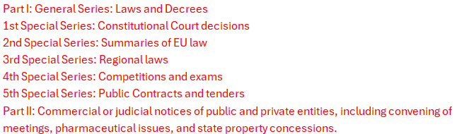

Since the scope is limited to national application, we proceeded under the assumption that only the General Series contains relevant ESG-related legislation, and this is the only series that has search filtering functionality. We extracted relevant ESG-related legislation exclusively from the General Series.

Could you kindly confirm whether this approach aligns with your expectations?

[Update from KLI 17-June-2025: Confirmed.]

## Extraction of Metadata

The results page displayed only the legislation titles. Keywords entered were emphasized in bold blue text. Example:

We extracted the full metadata by navigating the specific legislation text (please see screenshot below), and we determined it as follows:

* Source link – the URL of the legislation document.
* Original title – the complete title displayed on the page, labeled in red. We combined the short title and its long title, separated by a dash, to form the complete title. For example: [DECRETO LEGISLATIVO 3 aprile 2006, n. 152](https://www.gazzettaufficiale.it/atto/serie_generale/caricaDettaglioAtto/originario?atto.dataPubblicazioneGazzetta=2006-04-14&atto.codiceRedazionale=006G0171)



Complete Title:

*DECRETO LEGISLATIVO 3 aprile 2006, n. 152 - Norme in materia ambientale. (GU Serie Generale n.88 del 14-04-2006 - Suppl. Ordinario n. 96)*

For KLI: Is this title structure okay with you? Or do you have any preferred title format?

[Update from KLI 17-June-2025: Approved. Please include EN translation for clarity and consistency.]

* Type of regulation – inferred from the title, labeled in green:
* Legge (Law)
* Decreto (Decree)
* Decreto-Legge (Decree-Law)
* Regio Decreto (Royal Decree)
* Regio Decreto-Legge (Royal Decree-Law)
* Decreto Legislativo (Legislative Decree)
* Decreto del Presidente (Presidential Decree)
* Date of adoption – inferred from the title, labeled in blue.
* Entry into force date – identified by the term “in vigore” (into force) in the “Note” section, labeled in purple.

For KLI: Can you please confirm if our understanding is correct regarding the date of adoption and entry into force date?

[Update from KLI 17-June-2025: Confirmed.]

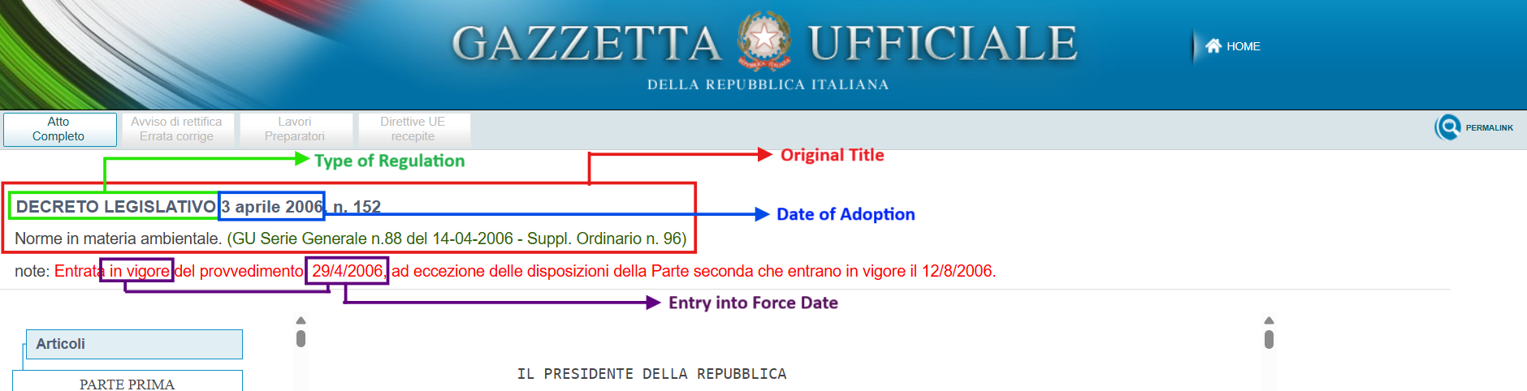

## Other Legislations

Upon further review, we discovered that some laws and decrees are listed in the [News Archive (Archivio Notizie)](https://www.gazzettaufficiale.it/showArchivioNews). However, this section does not provide a keyword search function; we accessed its contents only by manually browsing through year-based groupings.

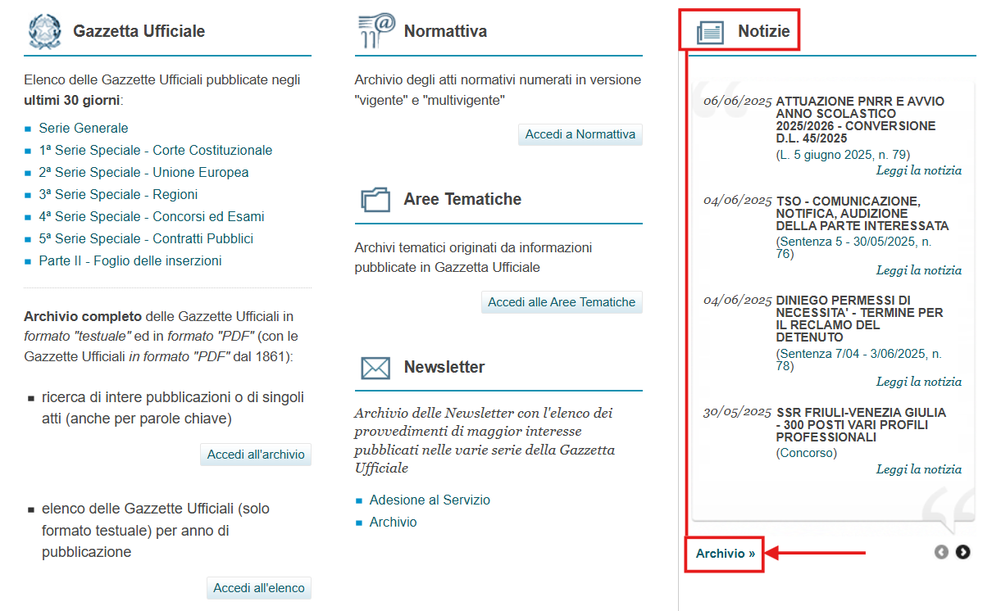

For example: [DECREE 21 December 2023 - Approval of the National Plan for Adaptation to Climate Change. (24A00953) (GU General Series no. 42 of 20-02-2024)](https://www.gazzettaufficiale.it/eli/id/2024/02/20/24A00953/sg)

Based on the above link, the document was published on 20 February 2024. We navigated the document to the year 2024.

For KLI: We understand that the *Approval of the National Plan for Adaptation to Climate Change* was mentioned in the ESG Country Guide Italy_67177 document. We would like to give a heads-up that any laws and decrees found in the News Archive cannot be retrieved or processed automatically, as we previously noted that its contents are accessible only through manual browsing of year-based groupings. This section does not support keyword-based search, so relevant legislation stored in this section will not appear in filtered search results or be captured through automated extraction.

[Update from KLI 17-June-2025: No need to include it.]